September 2022

Guideline for Filling in the Application Database file
“DB+Graduate School Code_KCCP2023.xlsx”

Please fill in the “Application Database file” based on “Application form” submitted by the applicants.

Other hints to fill in the database is as follows.

- Yellow column required field
- Gray column auto-fill or optional field

-Column A. Total No. (3digits):
Please assign a number for each candidate, starting with “001”, for each of the JICA long-term training course.This total number is used to create the “Reg. No.” in “Column F”.

<Note>
“Reg. No.” is used to identify each of the candidate. It is important to keep this number unique.

-Column B. Country Name (Nationality) :
Please select from the “drop down list”. Selecting the country name in this column, the “Country Code”(two-letter code) is automatically filled in “Column D”. This will also be used to create the “Reg. No.” in “Column F”.

-Column C. Name of Program:
Please select from the drop down list. Selecting the country name in this column, the“Program Code”is automatically filled in “Column E” .Thiswill also be used to create the “Reg. No.”in “Column F”.

-Column F. Reg.No:
Use the “Country Code”, “Program Code”, and the “Total No.” (in this order) to create the “Reg. No.”
Reg. No. will be used throughout the 2023 Fall application process. It must be in 6digit code combination of “Country Code”, “Program Code” and the “Total No.(3 digits)”.

“Reg.No”:
Country Code (Column D) + Program Code (Column E) + 3 digits Total Number (Column A)

-Column G. FAMILY NAME:
Enter in all caps.............ex) KOKUSAI
*An error message will show if you enter in lower case letters

-Column H. First name:
Use capital letter for only the first letter.............ex) Taro

-Column R. Tel. No. :
Please make sure to start with the country code

-Column Z-AC. Proficiency in English:
Please refer to the “University Information for Applicants (KCCP2023)”. If the desired university requires submission of score, this field is mandatory.

-Column AD. Research Topic:
Please enter your research title or topic

-Column AE. Graduate School Code:
Please refer to the “University Information for Applicants (JICA KCCP 2023)” and select candidate’s desired university carefully.Once entering the code correctly, the from columnsAF to AH, is automatically filled in.

-Column AI. Master or PhD:
Please Make sure to select which degree (Master or PhD.)the candidate is applying to.
Refer to the “[2023 Fall Admission] Acceptable JICA Long-Term Training Programs” under “University Information for Applicants (JICA KCCP 2023)” and also make sure the selected university/graduate school offers the desired degree under the desired JICA program.
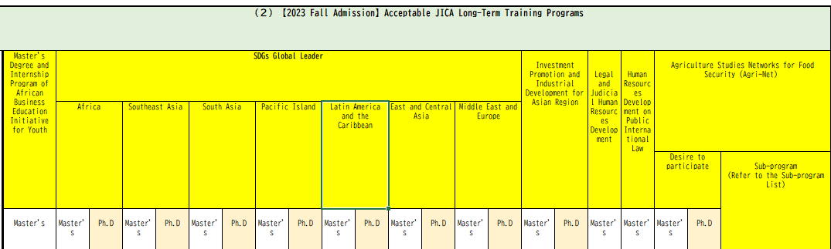

-Column AJ. Supervisor of choice:
Please refer to “Selection of supervisor for pre-application matching is required” in the “University Information for Applicants (JICA KCCP 2023)”.

For Master’ degree candidates:
If “Yes” is selected in “Colomn AQ”, it is mandatory to chose and fill in the name of preferred supervisor or otherwise the pre-application matching will not be properly conducted.

For PhD. degree candidates:
If “Yes” is selected in “Colomn AX”, it is mandatory to chose and fill in the name of preferred supervisor or otherwise the pre-application matching will not be properly conducted.

